Mobile Tester User Guide

Version: 1.1.2
DocCode: E-Tools-ALL-UG-2010-0002
Date: 2012-12-12


www.spreadtrum.com
Important Notice
Copyright Notice
Copyright © 2010, Spreadtrum Communications, Inc. All rights reserved.
Trademarks
Spreadtrum Communications, Inc. and Spreadtrum Communications, Inc.'s products are exclusively owned by Spreadtrum Communications, Inc. References to other companies and their products use trademarks owned by the respective companies and are for reference purpose only.
Warranty Disclaimer
Spreadtrum Communications, Inc. makes no representations or warranties, either expressed or implied, by or with respect to anything in this document, and shall not be liable for any implied warranties of merchantability or fitness for a particular purpose or for any indirect, special or consequential damages.
Confidentiality
The information contained herein (including any attachments) is confidential. The recipient hereby acknowledges the confidentiality of this document, and except for specific purposes, this document shall not be disclosed to any third party.
About This Document

Purpose
This document describes how to write IMEI into phone .

Intended Audience
This document is intended for users who want to write IMEI to phone.

Organization
This document consists of three chapters and is organized as follows.
Chapter | Describes
1 Operation Interfaces | Overview about Main interface and Setup interface of tool.
2 Operation Instructions | Details on use.
3 Configure File Setting | Describe the configuration file of tool.
Contents
1 Operation Interfaces 1-1
1.1 Main Interface 1-1
1.2 Setting Interface 1-2
1.3 Mode Select Interface 1-5
2 Operation Instructions 2-5
2.1 Choose Functions 2-5
2.2 Starting Writing 2-7
3 Configure File Setting 3-12
3.1 Configure File Setting 3-12

Figures
Figure 1-1 Main interface 1-1
Figure 1-2 Setting interface 1-2
Figure 1-3 Mode Selecte interface 1-5
Figure 2-1 Mode Select interface and Setting interface 2-6
Figure 2-2 Main interface 2-7
Figure 2-3 Starting interface on Working Mode 2-8
Figure 2-4 Starting interface on Normal Mode 2-9
Figure 2-5 Pass interface 2-9

Tables
Table 1-1 Main interface elements 1-2
Table 1-2 Setting interface elements 1-3

Operation Interfaces

Main Interface
Running WriteIMEI.exe, the main interface is shown as Figure 1-1.
              - Main interface
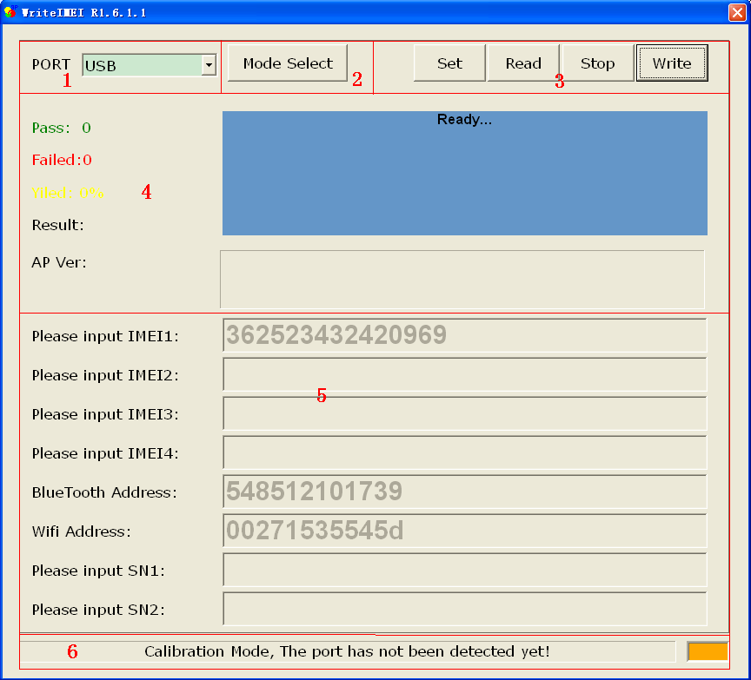
                - Main interface elements
Number | Description
① | Choose communication port that connects to phone, if the communication port is USB, please choose USB.
② | Mode Select button
③ | Function button.
④ | Current test result.
⑤ | Edit box for inputting IMEI and Bluetooth address.
⑥ | Port status indicator

Setting Interface
You can press “Set” button on the main interface to change the setting of WriteIMEI tool. The setting interface is shown as Figure 1-1.
              - Setting interface
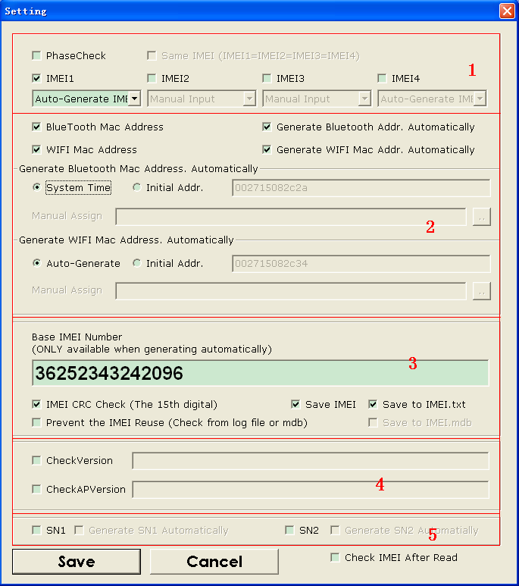
                - Setting interface elements
Number | Description
① | Setting of IMEI.
② | Setting of Blue Tooth and WIFI.
③ | The firs 14 number of IMEI when “Auto-Generate IMEI ” is checked.
④ | Setting of checking version, include software version and AP version.
⑤ | Setting of SN.

Mode Select Interface
You can press “Mode Sel” button on the main interface to change the Mode of WriteIMEI tool. The setting interface is shown as 1.2.1 Figure 1-11-3
              - Mode Selecte interface
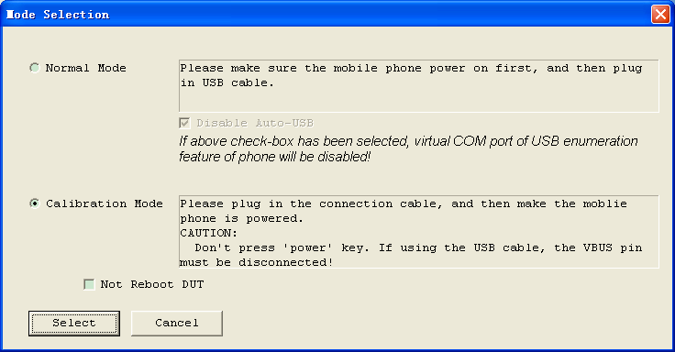

Operation Instructions

Choose Functions

Select the Work Mode on mode sel interface, and Check items on set interface, such as Figure 2-1.
              - Mode Select interface and Setting interface

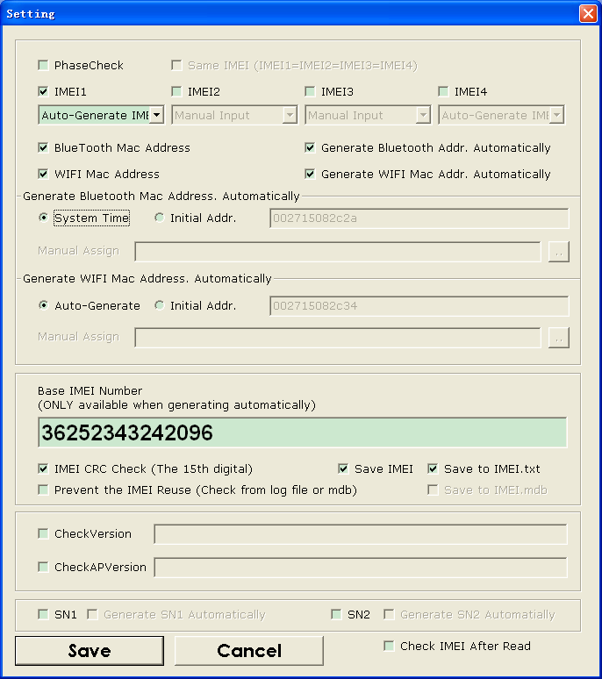

Press “Select”and“Save” button on Figure 2-1, then the main interface would be shown as Figure 2-2.
              - Main interface

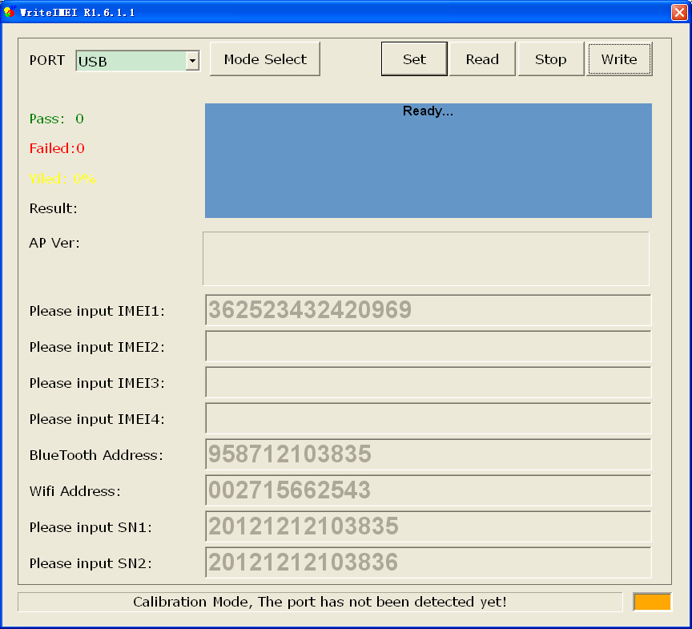

Starting Writing
            - Choose the port that connects to phone, If the tool mode is “Working Mode”, press “Write” button to start writing IMEI such as Figure 2-1.
              - Starting interface on Working Mode
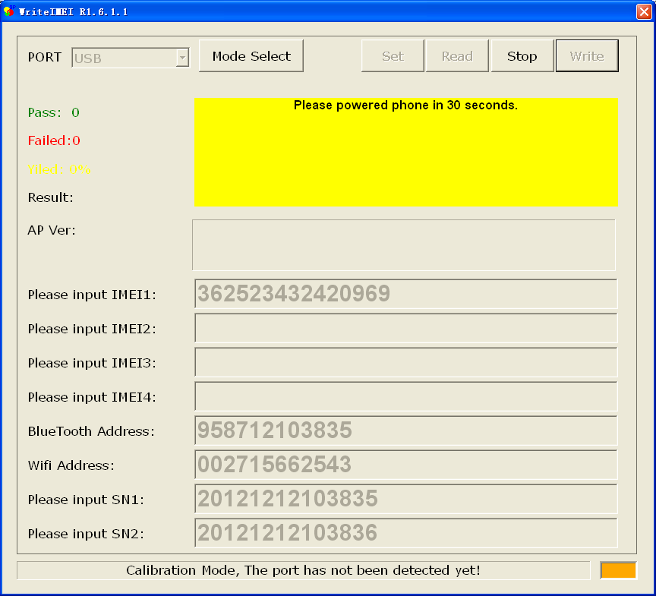

            - If the tool mode is “Normal Mode”, press “Write” button to start writing IMEI such as Figure 2-1.
              - Starting interface on Normal Mode
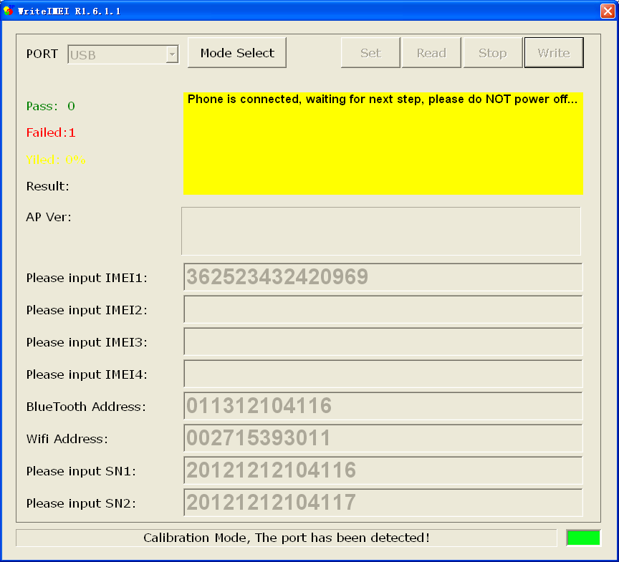

            - If the tool mode is “Normal Mode”, Power on the connected phone, wait for completing to write IMEI.
            - If the tool mode is “Working Mode”, wait for completing to write IMEI.
            - If pass, the result box will be green and display pass message as Figure 2-1, otherwise will be red.
              - Pass interface

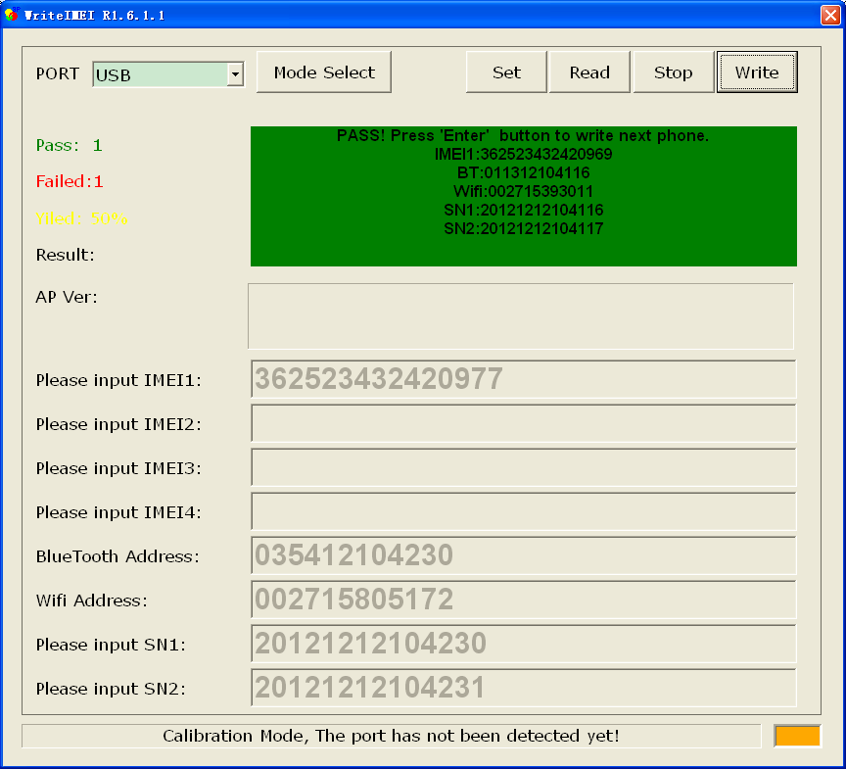

Configure File Setting

Configure File Setting
You can set some functions on the setting interface of WriteIMEI tool, also you can set some other functions in configure file (WriteIMEI.ini).
- TimeOut: The max times that waiting mobile to power on
- EntrerModeWait: The waiting time after mobile is set to work mode
- SN_LEN: Set length of SN.
- CheckStationName: Pre-station name for PhaseCheck.
- CurrentStationName: Current test station name for PhaseCheck.
- User Privilege: Enable the set button on main interface of tool.
- Language: Set language of tool, 1 - English, 0 – Chinese.
- MocorNew: Compatible for different version of phone software, normally it is to be default value of 1.

